DGKK Workshop on III/V Epitaxy 2021 - Abstract Template

A. AuthorSurname1,¹ B. AuthorSurname2,² …., N. AuthorSurnameN¹
¹ Affiliation1, City1, Country1
² Affiliation2, City2, Country2
⁺ Corresponding author: corresponding_author@electronic-mail.de

These instructions shall guide you preparing an abstract for the DGKK workshop on epitaxy of III/V semiconductors 2021 in Bremen. Please use this template for submitting an abstract. Configure your page in A4 format (21.0 cm x 29.7 cm) with left, top and right margins of 2.5 cm and bottom margin of 2 cm. Font: Calibri. Title: 16 points, centered, bold. Authors: 12 points, centered, bold. Affiliation: 12 points, centered, italic. Email address corresponding author: 10 points. Body text single-spaced, 12 points. The presenting author should be underlined. Leave one blank line after the affiliation of authors and start your abstract without writing the word “Abstract”. Abstracts must be written in English. Only a pdf version of the abstract should be submitted. It will be shared electronically between the workshop participants. without any modifications. References in the text should be mentioned in square brackets [1] and should be listed after one blank line after the figure captions using 10 points characters.

Each abstract must be a single page in length (including figures). Abstracts are submitted for oral presentation on a first come – first served basis. The organizers might decide on a poster presentation by November 7, 2021.
Please submit the pdf version to dgkk2021@ifp.uni-bremen.de by October 10, 2021.

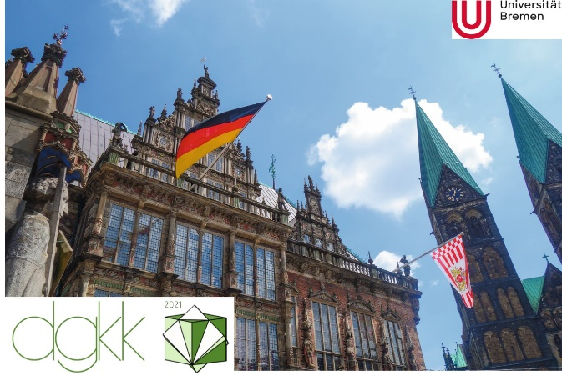 | 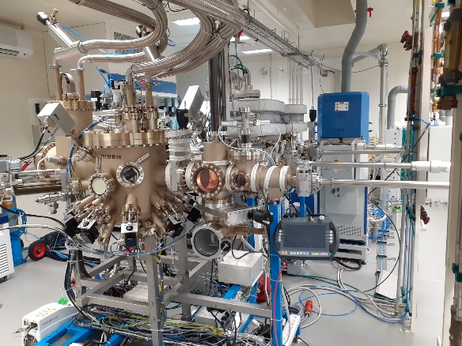
Fig. 1: Caption Figure 1  (Figures and captions are displayed in a table). | Fig. 2: Caption Figure 2

[1] F. Capasso, K. Mohammed, and A. Y. Cho, J. Vac. Sci. Technol. B 3, 1245 (1985).

