Professorship for Global Supply Chain Management
Chair Holder: Prof. Dr. Aseem Kinra

Term paper on the subject of
Applying ABC method to improve supply chain performance(example)

From: Mustermann, Max(example)
Matriculation No.: 2443555
Degree course: Business administration
Supervisor: Prof. Dr. Kinra
Processing time:

Table of Contents
Table of Contents II
List of Figures III
List of Tables IV
List of Abbreviations V
Preface VI
Citation rules VII
1 Introduction to the problem field 1
2 Analysis 2
3 Conclusion and Reflection 3
4 Bibliography 4

List of Figures
Figure 1: Necessary website information for the citation X

List of Tables
Table 1: Representation of quotes in the bibiliography including examples IX

List of Abbreviations
CC | Core Category

Preface
Dear students,
The term paper should be in between 10-15 pages. Below you will find the formatting specifications for completing your term paper at the Chair of Global Supply chain and Management. You can use this document as a template for your work or format your own document. When using the template, please delete the chapter Preface and Citation Rules. If you decide to format your own document, please follow these formatting instructions exactly:
1. Font:
- Font: Times New Roman (as well as in the footnotes)
- Font size: 12 point in the main text, 10 point in the footnotes
- Line spacing: 1.15, after a paragraph 12 point
- First level headers are always starting at a new page (page break)
- Justification
- Pagination: Roman numerals for table of contents, list of figures, list of tables and list of abbreviations, Arabic numerals for main text, references and appendix, Times New Roman, 9 point, right-justified in footer
- Labelling of figures and tables: Times New Roman, 9 point, line spacing 1.15, before a paragraph 6 point, after a paragraph 10 point, labelling for figures below the element, labelling for tables above the element
2. Layout:
- Margin: 2 cm bottom, 2.5 cm left/right/top
- Header line: First level headers, right-justified, Times New Roman, 9 point
- Footer: Name and surname, left-justified, Times New Roman, 9 point

Citation rules
In general, you should provide references to any statements you make in your scientific work. This serves to make your explanations comprehensible and verifiable for readers. It is quite common to cite several sources for a statement. Please note: All references cited in the text must also be included in the bibliography.
Below you will find the citation rules that you must follow when writing a scientific paper at the Chair of Global Supply chain and Management.
Citation in the text
It can be distinguished between direct and indirect quotes. Direct quotes reflect the statement of an author word for word. Check if the use of a direct quote is appropriate or necessary. Citations in the text differ significantly from those in the bibliography! (see point 2.2.)
Indirect quotes:
Indirect quotes are the normal case and are not especially highlighted in the text.
- For one or two authors: The text is completed by the following information in parentheses: (Last name, Year of publication, Page).
- More than two authors: From a number of three authors, only the first author is mentioned by name and "et al." refers to the other authors.
- Multiple sources for a statement: If a text passage is proved by multiple sources, the two sources are separated by a semicolon. The reference looks like this: (Last name, Year of publication, Page; Last name, Year of publication, Page). The sources are chronologically ranked in ascending or descending order.
- Internet sources: Either the author (see example 1) or the organization that runs the website should be mentioned in the text. Add the year and, if available, the page number. If page information is missing: n.p. Also include the date and time of access.
- Several bibliographical references from an author or an Internet source in the same year: For citations by a writer from different sources with the same year of publication, this one must be consequently numbered by a lower-case letter.
- Compilation: If a contribution from a compilation is cited, the author of the respective contribution is cited (and not the author of the compilation)
- No authors stated: In rare cases sources are cited without an author. Here you enter Anon as an author

The following examples explain the stated points:
Examples:
…Text…(Klaus, 2005, p. 31).
….Text…(Kinra et al., 2017, p. 80)
…Text…(Kotzab and Reutterer, 1999, p. 183-185).
…Text…(Quiett, 2002, p. 41; Vahrenkamp, 2005, p. 164; Weber and Wallenburg, 2010, p. 89).
…Text…(Real, 2011a, n.p.)
…Text…(Anon, 2002, p. 11)
Direct quotes:
Direct quotes should be used sparingly. They are embedded in the text by “quotation marks” and closed in brackets by the following reference: (Last name, Year of publication, Page).
Example:
„The lack of a rigorous and generally accepted theory of logistics at the present time is serious impediment to making actual military logistical operations as effective as desired, although immensely complicated situations have been met, somites with surprinsingly minor noticeable deficiencies” (Morgenstern, 1955, p. 129).
Sub quotes:
If it is not possible to obtain an original source, you must use sub quotes. However, sub quotes should only be used if the primary source is missing or unreachable for you (for example, there is only one copy of a monograph left in the library of the University of Saskatchewan in Canada). Therefore, sub quotes are the absolute exception in your work.
If you need to use sub quotes, they will appear in the following form:
((Last Name, Year of Publication, Page) quoted from (Last Name, Year of Publication, Page)).

Example:
…Text…(Jomini, 1881 quoted from Gudehus, 2010, p. xix).

Please note that both primary source (= Jomini) and secondary source (= Gudehus) must appear in the bibliography!
Citation in the bibliography
At the end of your paper, a bibliography arranged in alphabetical order must be compiled. The bibliography is similar to a recipe because it shows your effort for the paper. Only those sources that were actually used visibly in the work are listed in the bibliography. Conversely, that means that all references listed in the bibliography can also be found in the text at least once.
Please note the citation rules for books, compilations, journals, internet sources and sources without an author. The following table gives you an overview.
Table 1: Representation of quotes in the bibliography including examples
 | Citation in the bibliography | Example
Book | Last name, First name (Year of publication): Title. Edition. Place of publication: Publisher. | Gudehus, Timm (2010): Logistik. Grundlagen, Strategien, Anwendungen. 4th Edition. Heidelberg et al.: Springer.
Compilation | Last name, First name (Year of publication): Title. In: Last name, First name (ed.): Title. Place of publication: Publisher, Page. | Schnedlitz, Peter/Kotzab, Herbert/Teller, Christoph (2004): Die Kunden als Erfüllungsgehilfen des stationären Einzelhandels bei der physischen Distribution von Waren. In: Trommsdorff, Volker (ed.): Handelsforschung 2002. Neue Erkenntnisse für Praxis und Wissenschaft des Handels. Köln: BBE-Verlag, pp. 87-106.
Journal | Last name, First name (Year of publication): Title. In: Journal title, Issue number, Page. | Morgenstern, Oskar (1955): A Note on the Formulation of the Theory of Logistics. In: Naval Research Logistics, 2 (3), pp. 129-136. Trends in Large Scale Retailing.
Internet source | Last name, First name (Year): Title. Available at: Web address (Accessed: dd.mm.yy; [MEZ] hh:mm am/pm). | Real (2011): Die real,- SB-Warenhaus GmbH. Online available at: http://www.real.de/unternehmen/das-unternehmen-real.html (Accessed: 30.10.2011; [MEZ] 01:06 pm).
Source without an author | Citation like book/compilation/journal/internet source. Instead of the author’s name: Anon | Anon (2002): „Dossier Globale Handelsstrukturen“. In: LP-International 11/02, pp. 10-13.
Note on publications from the internet
The web address itself is not enough for a reference in science. The state corresponds to the day the page was created or modified. Just click the right mouse button on the cited page and search for the information on the creation or modification date. There is also the exact link for the internet source.
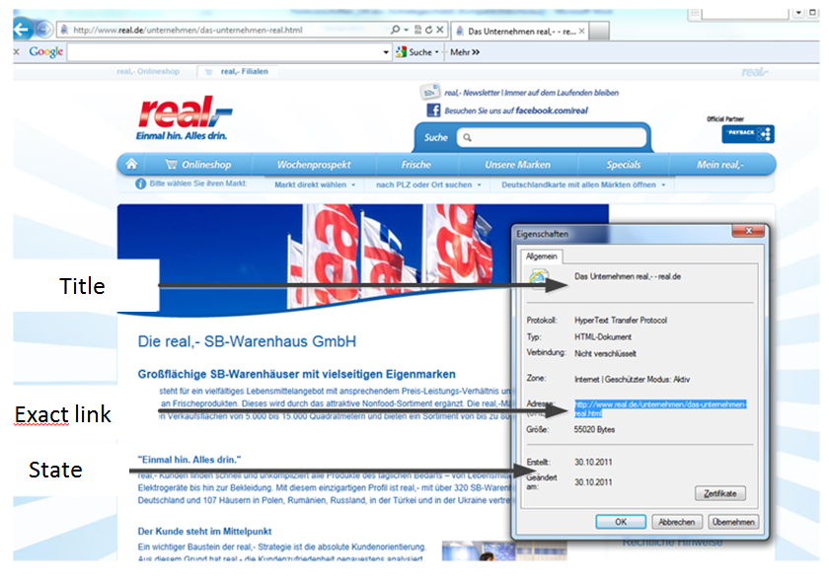
Figure 1: Necessary website information for the citation
If you quote the homepage of a company, please state the respective company as the author.
Example:
Langley, John/CapGemini (2010): 2010 Third-Party Logistics. The State of Logistics Outsourcing. Results and Findings of the 15th Annual Study. Available at: http://www.scl.gatech.edu/research/supply-chain/20103PLReport.pdf (Accessed: 30.10.2010; [MEZ] 09:22 am).

Introduction to problem field
Terms papers are usually topic based. Therefore, this part will include the introduction part where the main topic of investigation to be discussed and a problem statement is to be formed. Based on the same, the fundamental things in regards to the topic would be discussed- how this is related to various other aspects within the sate of art, its complete approach and its different categories. To framework all the sections, other literatures can be used but the main focus should be on the literature used for the course. This introduction section should be around 3- 4 pages.

Analysis
This section will portray an analysis on how the main topic considered can be connected to global supply chain management. This may be with the help of question and answer based approach, use cases or providing scenarios, etc., which would provide a practical relevance in topic in hand and how, when and where can this method can be applied to optimize the current problem in the research field. As this is the main part of the paper, this should be within 5-7 pages.

Conclusion and Refection
In this section, this should showcase whether the main objective of the paper is fulfilled. If yes, then how is it fulfilled- the complete overview. It should also include the part where it can provide an overview on how the method considered for the paper is better or worse than some of the other methods/fields mentioned in the course literature and what limitations do they have in general. This should be within 3-4 pages.
4 Example of a bibliography
Bänsch, Axel (2008): Wissenschaftliches Arbeiten. Seminar- und Diplomarbeiten. 8th Edition. München: Oldenbourg.
DHL (2010): Delivering Tomorrow: Zukunftstrend Nachhaltige Logistik. Online available at: http://www.dpdhl.com/content/dam/logistik_populaer/trends/StudieSustainableLogistics/dpdhl_delivering_tomorrow_studie.pdf (Accessed: 16.10.2010; [MEZ] 10:50 am).
Eriksdotter, Holger (2010): IT-Management. Tchibo lagert aus. Online available at: http://www.manager-magazin.de/unternehmen/it/0,2828,641188,00.html (Accessed: 22.10.2010; [MEZ] 11:11 am).
Gudehus, Timm (2010): Logistik. Grundlagen, Strategien, Anwendungen. 4th Edition. Heidelberg et al.: Springer.
Klaus, Peter (2005): Die Fragen der optimalen Komplexität in Supply-Chains und Supply-Netzwerken. In: Eßig, Michael (ed.): Perspektiven des Supply Management – Konzepte und Anwendungen. Berlin et al.: Springer, pp. 361-375.
Kolmogorovs, Vadims (2007): Logistics outsourcing - a way to increase efficiency. Saarbrücken: VDM Verlag Dr. Mueller e.K.
Kinra, Aseem/Kotzab, Herbert (2008): Understanding and measuring macro‐institutional complexity of logistics systems environment. In: Journal of Business Logistics, 29(1), S. 327-346.
Kinra, Aseem/ Mukkamala, Raghava R/ Vatrapu, Ravi (2017): Methodological demonstration of a text analytics approach to country logistics system assessments. In: In Dynamics in Logistics: Springer S. 119-129.
Kotzab, Herbert/Reutterer, Thomas (1999): Anforderungen an Logistik-Systeme aus Anwendersicht - Eine empirische Studie mit Hilfe der Conjoint-Analyse. In: Logistik-Management, 1 (3), pp. 181-197.
Kotzab, Herbert/Teller, Christoph/Girz, Heidrun R. (2009): The GS1 Databar and Its Future Application - Results from a Delphi Study. In: European Retail Research, 23 (2), pp. 1-190.
Kotzab, Herbert/Völk, Natalie/Keusch, Matthias/Leitner, Markus (2010): Stand und Entwicklungstendenzen des Supply Chain Management in Österreich. In: Engelhardt-Nowitzki, Corinna/Nowitzki, Olaf/Zsifkovits, Helmut (ed.): Supply Chain Network Management. Gestaltungskonzepte und Stand der praktischen Anwendung. Wiesbaden: Gabler, pp. 339-354.
Lambert, Douglas M./Cooper, Martha C. (2000): Issues in Supply Chain Management. In: Industrial Marketing Management, 29 (1), pp. 65-83.
Morgenstern, Oskar (1955): A Note on the Formulation of the Theory of Logistics. In: Naval Research Logistics, 2 (3), pp. 129-136. Trends in Large Scale Retailing.
Anon (2000): Outsourcing. In: Gabler Wirtschaftslexikon, 15th Edition. Wiesbaden. pp. 2344-2345.
Anon (2002): „Dossier Globale Handelsstrukturen“. In: LP-International 11/02, pp. 10-13.
Real (2011): Die real,- SB-Warenhaus GmbH. Online available at: http://www.real.de/unternehmen/das-unternehmen-real.html (Accessed: 30.10.2011; [MEZ] 01:06 pm).
Sinha, Amit/Kotzab, Herbert (2011): Supply Chain Management. A Managerial Approach. New Delhi et al.: Tata McGraw Hill Education Private Limited.
Schnedlitz, Peter/Kotzab, Herbert/Teller, Christoph (2004): Die Kunden als Erfüllungsgehilfen des stationären Einzelhandels bei der physischen Distribution von Waren. In: Trommsdorff, Volker (ed.): Handelsforschung 2002. Neue Erkenntnisse für Praxis und Wissenschaft des Handels. Köln: BBE-Verlag, pp. 87-106.
Vahrenkamp, Richard/ Siepermann, Christoph (2005): Logistik - Management und Strategien. 5th Edition. München et al.: Oldenbourg.
Weber, Jürgen/Wallenburg, Carl M. (2010): Logistik- und Supply Chain Controlling, 6th Edition. Stuttgart: Schäffer-Poeschel.
For easier handling of the citations it is recommended to use citation programs such as RefWorks, Zotero or Citavi. Information and instructions can be obtained from the university library.
It should be pointed out again that Wikipedia is not a citable source for university papers.
Please remove this info box if you use the style sheet.

Affidavit
I hereby declare that I have produced the present work independently and without the use of any aids other than those specified. All passages that have been taken literally or analogously from published or unpublished writings are marked as such. The paper has not yet been submitted in the same form or in extracts in the context of other examinations.
Bremen, 18.02.2020 ________________________
Max Mustermann

